# Experiment 1

**Aim: Design of basic binary adders and subtractors.**

**Exercise 1:** Design half adder in **data flow style** of modeling.

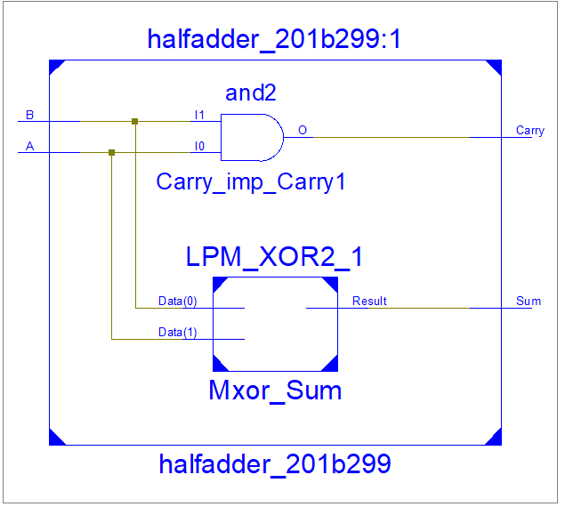**Design code:**

library IEEE;

use IEEE.STD_LOGIC_1164.ALL;

entity halfadder_201b299 is

Port ( A : in STD_LOGIC;

B : in STD_LOGIC;

Sum : out STD_LOGIC;

Carry : out STD_LOGIC);

end halfadder_201b299;

architecture Dataflow of halfadder_201b299 is

begin

Sum <= A xor B;

Carry <= A and B;

end Dataflow;

**Test Bench:**